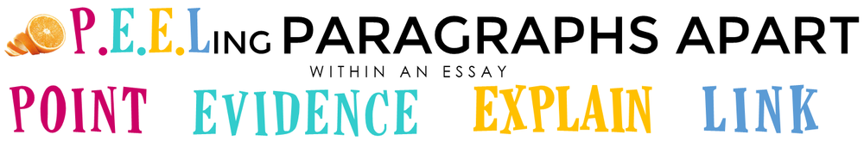

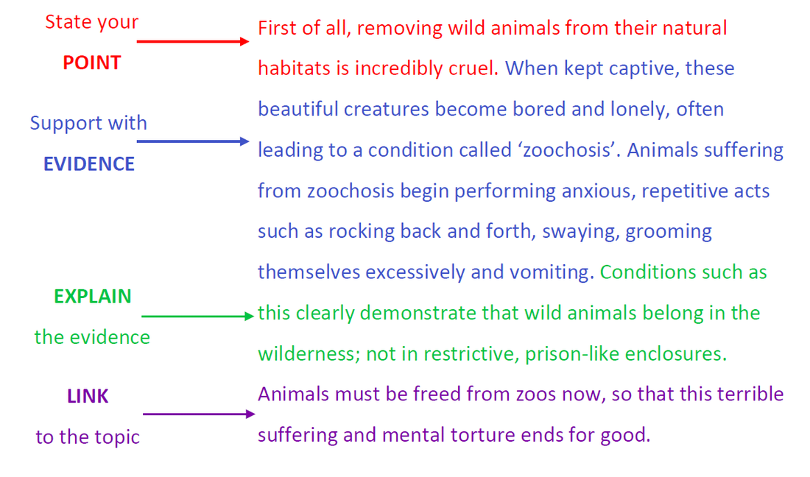
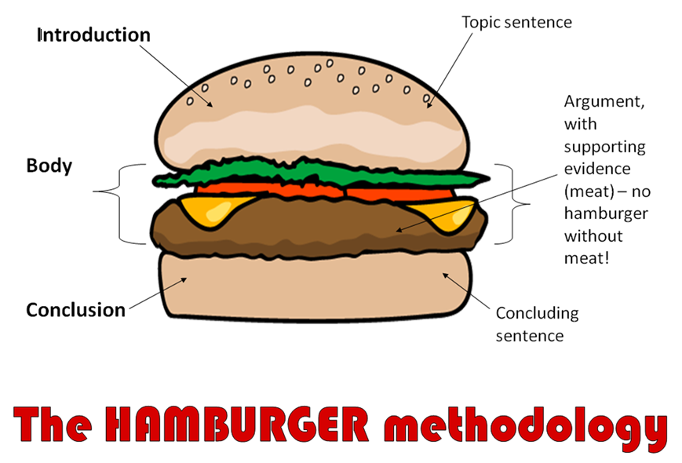
Example of a PEEL paragraph.
Questions to help write your BODY PARAGRAPHS for your essay:

        - How do characters portray light vs dark OR good vs evil?
        - How do poetic devices create a sense of light vs dark OR good vs evil?
        - How does the atmosphere create a sense of light vs dark OR good vs evil?
        - What does the poet teach us about human experiences?

